1 - 4 – Inverses – Practice
1. [C/P]
a). To verify two functions f and g are inverses it must be true that $f\left(g\left(x\right)\right)=what?$ And $g\left(f\left(x\right)\right)=what$ ? Explain this algebraic condition in regular English; what important idea about inverses does it capture? (just need 1 good sentence here).
b). Use the check from part (a) to see whether $f\left(x\right)=\frac{1}{x-1}$ and $g\left(x\right)=\frac{1}{x}+1$ are inverses.
c). Is $\frac{1}{sin⁡(x)}$ the inverse of $sin(x)$ ? Use the check from part (a) to see.

2. [P] Find the inverse of each.
a. $g\left(x\right)=\sqrt[7]{3-2x}$
b. $h\left(x\right)=\frac{2}{x+1}$
c. $h\left(x\right)=\frac{x}{x+1}$
d. $f\left(x\right)=\frac{1}{2}⋅3^{1-x}+5$

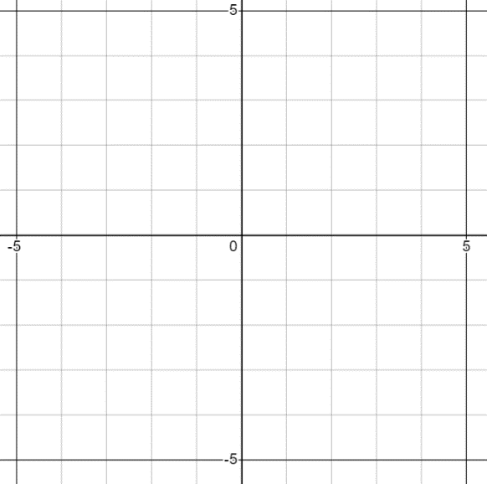
3. [C] Here’s the graph of $y=f(x)$.
(-3,-4)
(0, -1)
(1,1)
(5,2)

a). What’s f(-3) ? What’s $f^{-1}\left(-1\right) ?$

b). What are two coordinates points you know are on the graph of $y=f^{-1}(x)$ ?

c). Are there any points that are on both $y=f(x)$ and $y=f^{-1}(x)$?

d). The domain of f is $-3≤x≤5$ and the range is $-4≤y≤2$
What’s the domain and range of $f^{-1}$ ?

([verbal only] notice the relationship between domain+range of a function and its inverse. Why should it make sense your answer ended up that way?).

4. [P] Find the inverse of...
a). $f\left(x\right)=\frac{{\left(3-2x\right)}^{5}}{4}$
b). $f\left(x\right)=\frac{3}{x-5}$

5. [C] If $g\left(x\right)=2^{x}+x$, give the coordinates for 3 points that are on the graph of $y=f^{-1}(x)$

6. [C] Suppose $h(x)=f^{-1}\left(g\left(x\right)\right)$. If $f\left(3\right)=2$, $g\left(5\right)=3$, $f\left(1\right)=3$ and $g\left(4\right)=10$ find $h\left(5\right).$

7. [C] True or False:
a). T/F: If f and g are inverses and (1,7) is a point on f, it must be true that $f\left(1\right)=7$ and $g\left(7\right)=1$
b). T/F: If $f\left(1\right)=7$ and $g\left(7\right)=1$, then f and g must be inverses

*8. [C/P] The next two require careful thinking. Remember that inverses have swapped domain and range. Don’t worry if you can’t get it, but read the solution and try and focus on what my strategy/logic were for finding the domains.
*a). $f\left(x\right)=4\sqrt{2-\sqrt{x}}$ . What’s the domain of $f^{-1}$ ?
*b). $f\left(x\right)=2^{4-x^{2}}$ for $x≥0$. Find the inverse and its domain.

1 - 4 – Inverses – Solutions
1. [P/C]
a). To verify two functions f and g are inverses it must be true that $f\left(g\left(x\right)\right)=what?$ And $g\left(f\left(x\right)\right)=what$ ? Explain this algebraic condition in regular English; what important idea about inverses does it capture?
f and g are inverses if they undo the action of the other one. Put differently: whatever one function does to an input to change it to an output, the other one does the reverse process that will undo it. So, for example, if f(5) is a number, and g( that number ) should produce 5 again. You can write this idea as: $f\left( g\left(some input\right)\right)=same input$. Mathematicaians just use the variable x to indicate that this works with any number. Therefore we’d expect that $f\left(g\left(x\right)\right)=x$ and $g\left(f\left(x\right)\right)=x$.
b). Use the check from part (a) to see whether $f\left(x\right)=\frac{1}{x-1}$ and $g\left(x\right)=\frac{1}{x}+1$ are inverses.
Let’s check by finding $f\left(g\left(x\right)\right)$. Plugging g(x) into the x in the f equation gives: $\frac{1}{\left(\frac{1}{x}+1\right)-1} → \frac{1}{\left(\frac{1}{x}\right)} → x$, so they are inverses.

c). Is $\frac{1}{sin⁡(x)}$ the inverse of $sin(x)$ ? Use the check from part (a) to see.
Here the answer is definitely not.
If $f\left(x\right)=sin(x)$ and $g\left(x\right)=\frac{1}{sin(x)}$, we find $f\left(g\left(x\right)\right)=sin\left(\frac{1}{sin(x)}\right)$ which can’t be simplified and isn’t x. So they definitely aren’t undoing each other. You could also check this with simple numbers you know: $sin\left(\frac{π}{2}\right)=1$ . Is $\frac{1}{sin(1)}$ going to give us $\frac{π}{2}$ back again? Nope.
2. Find the inverse of each.
You can use AI to help you think through the algebraic steps if you need.
a. $g\left(x\right)=\sqrt[7]{3-2x}$ $g^{-1}\left(x\right)=\frac{3-x^{7}}{2}$
b. $h\left(x\right)=\frac{2}{x+1}$ ‘
For problems b and c the big strategy is: move all the terms with y to the left and everything else to the right.
$h^{-1}\left(x\right)=\frac{2-x}{x}$ or $\frac{2}{x}-1$ (note: you wouldn’t ordinarily write a domain restriction since the function itself shows that $x≠0$)
c. $h\left(x\right)=\frac{x}{x+1}$ $h^{-1}\left(x\right)=\frac{-x}{x-1}$
d. $f\left(x\right)=\frac{1}{2}⋅3^{1-x}+5$ $f^{-1}\left(x\right)=1-\log_{3}\left(2x-10\right)$


3. Here’s the graph of $y=f(x)$.
(-3,-4)
(0, -1)
(1,1)
(5,2)
a). What’s f(-3) ? 4 What’s $f^{-1}\left(-1\right) ?$ $0$
b). Sketch the graph of $y=f^{-1}(x)$

[just reflect it around y = x … plot each point with (x, y) swapped and connect the dots].

c). The domain of f is $-3≤x≤5$ and the range is $-4≤y≤2$
What’s the domain and range of $f^{-1}$ ?

$f^{-1}$ has domain $-4≤x≤2$ and range $-3≤y≤5$. They’ve swapped. Which makes since, because the inverse function swaps inputs and outputs (since it’s the reverse function). So the set of valid inputs becomes the set of valid outputs and vice versa.

4. Find the inverse of...
a). $f\left(x\right)=\frac{{\left(3-2x\right)}^{5}}{4}$ $f^{-1}\left(x\right)=\frac{3-\sqrt[5]{4x}}{2}$
b). $f\left(x\right)=\frac{3}{x-5}$ $f^{-1}\left(x\right)=\frac{3+5x}{x}$

5. [C] If $g\left(x\right)=2^{x}+x$, give the coordinates for 3 points that are on the graph of $y=f^{-1}(x)$.
If your strategy is to find $g^{-1}$, and then plug in some x values to find y-values, you’ll find that it isn’t going to work. $g(x)$ has a valid inverse function, but it can’t be written down using elementary functions.
Here’s a different strategy. Find three (x, y) coordinates on $y=g(x)$ and then reverse them. Plugging in x = 0, 1 and 2 we get $(0, 1)$, $(1,3)$ and $\left(2, 6\right)$.
Therefore, we know the inverse function must have the points $\left(1,0\right), \left(3, 1\right), and \left(6, 2\right).$

6. [C] Suppose $h(x)=f^{-1}\left(g\left(x\right)\right)$. If $f\left(3\right)=2$, $g\left(5\right)=3$, $f\left(1\right)=3$ and $g\left(4\right)=10$ find $h\left(5\right).$
If x = 5, $h(5)$ is $f^{-1}\left(g\left(5\right)\right)$. $g(5)$ is 3, so now we have $f^{-1}(3)$. I see that f turns 1 into 3, so f-inverse must turn 3 into 1. Therefore the answer 1.

7. [C] True or False:
a). If f and g are inverses and (1,7) is a point on f, it must be true that $f\left(1\right)=7$ and $g\left(7\right)=1$
TRUE. This follows from the definition of what it means to be inverses. You know f and g undo each other for all inputs, so this must include the input of x = 1.
b). If $f\left(1\right)=7$ and $g\left(7\right)=1$, then f and g must be inverses
FALSE. The answer is no because it might be that f and g don’t actually undo each other for any other values. So they aren’t necessarily inverses.
The reason I asked this question was just to show you that (a) and (b) aren’t asking the same thing. It’s very common in math to see that IF (A is true) THEN (B is true) and then wonder whether the reverse also holds: if (B is true) THEN (A is true). Sometimes it does and sometimes it doesn’t; you have to think about it separately.

8. [C/P]
a). $f\left(x\right)=4\sqrt{2-\sqrt{x}}$
You could find the inverse function here, but it’s not necessary. It doesn’t help you find the domain because the domain of $f^{-1}$ is restricted due to the restrictions built into the square root functions in f.
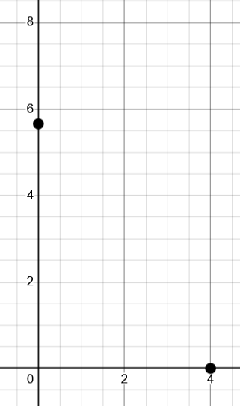
Better to first think about the domain of $f\left(x\right)$. I know $x≥0$ AND $\left(2-\sqrt{x}\right)≥0$ which simplifies to $x≤4$. So f has a domain of $0≤x≤4$. The two endpoints are $(0, 4\sqrt{2})$ and $(4,0)$. Since the inverse function reflects these around $y=x$, they become $(0, 4)$ and $\left(4\sqrt{2},0\right)$. So the range of f has become the domain of $f^{-1}$ giving $0≤x≤4\sqrt{2}$.
Was this reasoning too sloppy? Maybe. We claimed that the range of $f(x)$ was all the y-values between the two end-points of the domain. But how do we know something like this picture isn’t happening? If it were, the range would be larger than what we said (meaning the domain of the inverse would be wrong).
One reassurance is that the “hump” that’s causing our worry would also mean that $f(x)$ doesn’t have an inverse that’s a function. So if you convince yourself that $f^{-1}$ is a function, then you know $f(x)$ can’t have a “hump” like that.
Alternatively, you could try and convince yourself that $f(x)$ is a one-to-one function, and therefore can’t have a hump like that. A good way to do that is to imagine the general shape of $f\left(x\right)$ built up one step a time.
$$y=\sqrt{x}$$ | $$y=-\sqrt{x}$$ | $$y=2-\sqrt{x}$$ | $$y=\sqrt{2-\sqrt{x}}$$ | $$y=4\sqrt{2-\sqrt{x}}$$
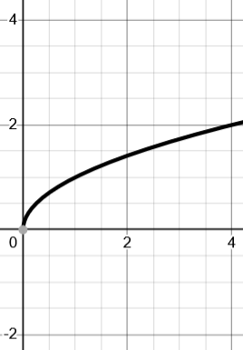 | 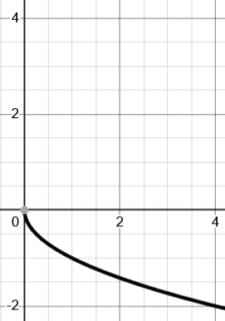 | 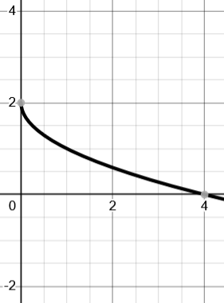 | 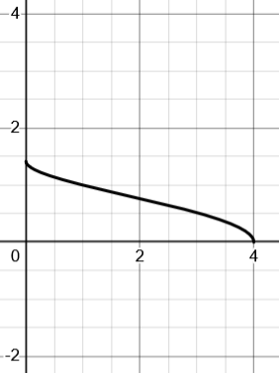 | 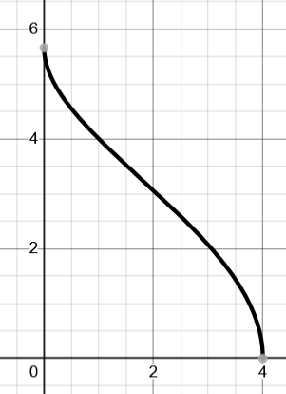

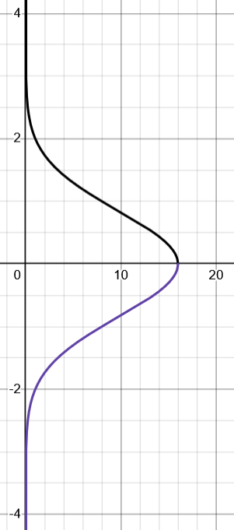
d). $f\left(x\right)=2^{4-x^{2}}$
$$y=+\sqrt{4-\log_{2}\left(x\right)}$$
$$y=-\sqrt{4-\log_{2}\left(x\right)}$$
Solving for the inverse gives $y=±\sqrt{4-\log_{2}{(x)}}$, but we know it can’t be both + and -.
The reason why is that $+$ and $-$ is really saying there’s two graphs: $y=+\sqrt{4-\log_{2}{(x)}}$ and $y=-\sqrt{4-\log_{2}\left(x\right)}$. I’m not suggesting you need to know what the shape looks like, but it’s good to know that $y=±somthing$ splits into a $y=+something$ and a symmetric $y=-something$.
Which should we keep? You might think about plugging in individual points. The original domain restriction on f was $x≥0$.
The endpoint of the domain for f(x) is at (0, 16) (which you get by plugging in x = 0). That means (16, 0) is on the inverse. This hasn’t helped us decide if we keep the + branch or the – branch, though, because $+\sqrt{0}$ is the same as $-\sqrt{0}$. So let’s do one more point. If x = 1, $f\left(1\right)=8$. That means (8, 1) should be on the inverse, so we keep the + branch.
A much easier way to see this is to think: the domain and range swap. Since the domain of f(x) is positive numbers, that means the range of $f^{-1}$ must be $y≥0$. So clearly $y=-\sqrt{4-\log_{2}{(x)}}$ doesn’t fit that description.
Now we know the inverse is $f^{-1}=\sqrt{4-\log_{2}{(x)}}$ . What’s the domain? Let’s think about the range of $f\left(x\right)=2^{4-x^{2}}$ when $x≥0$. When x = 0, $f\left(0\right)=16$. As x gets larger, the exponent gets smaller. So if x were very large, we’d have $\left( BIG x , 2^{\left(SMALL value\right)}\right)$. Since $2^{SMALL VALUE}$ is close to 0, we have a range of $(0, 16]$. Therefore $f's$ domain is $0<x≤16$. You could get this same result by solving the inequality $\left(4-\log_{2}\left(x\right)\right)≥0$ but it may be less clear what to do with the greater-than sign when you undo log. So imagining the range of f is probably easier.

1 - 4 – Inverses – Practice 2
1). Consider $f(x)={\left(x-2\right)}^{2}$
a). Why isn’t f invertible? (in other words, why isn’t the inverse of f a function?)
b). Which of the following domain restrictions would make it invertible? Why?
i. x > 0 ii. x < -2 iii. x < 2 iv. x > 3 v. x < 3
c). If we restrict the domain to $x≥10$, find $f^{-1}$ and give its domain.
2). Find the inverse of each function:
  - Given $q\left(x\right)={(x+5)}^{2}-1$ restricted to $x≥1$, find $q^{-1}$.
equation for $q^{-1}$: _____________________
domain of $q^{-1}$: __________________________

  - $f\left(x\right)=3^{x-2}+1$, restricted to $3≤x≤5$, find $f^{-1}$.
equation for $f^{-1}$: _____________________
domain of $f^{-1}$: _________________________

3). Find the inverse function for each and give the domain of the inverse.
a). $f\left(x\right)=\sqrt{1+2x}$ [ This is a root-shaped graph; what x-value is the “vertex” ? That should help with the domain of $f^{-1}$ ]
b). $f\left(x\right)={\left(x^{3}-1\right)}^{5}$
c). $f\left(x\right)=\frac{2x+1}{x+3}$

4). Here is $y=f(x)$. Which of the following domain restrictions would make $f(x)$ invertible? (ie f’s inverse is a function)
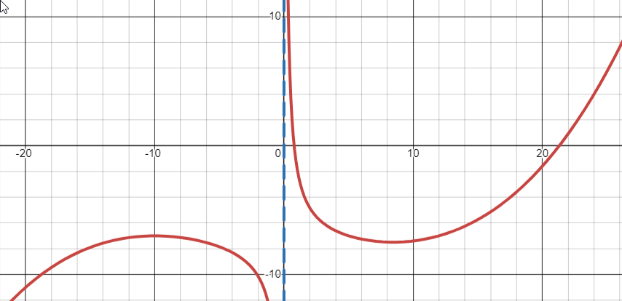
a). if $x<0$ ______
b). if $10≤x≤20$ ______
c). if $0<x≤6$ ______
d). if $0<x≤12$ ______
d). if $x≤-12$ ______

5). For each function, write either “invertible” if you can invert it without restricting the domain, OR write a domain restriction for the function that would allow it to be invertible.
$h\left(x\right)={11}^{-x}$ ___________________________
$a\left(x\right)={\left(x+3\right)}^{31}$ ___________________________
$f\left(x\right)=\frac{x-1}{2}$ ___________________________
$g\left(x\right)=x^{12}+2$ ___________________________

1 - 4 – Inverses – Solutions
1). Consider $f(x)={\left(x-2\right)}^{2}$
a). Why isn’t f invertible?
Because the inverse would be $y=2±\sqrt{x}$ which isn’t a function since a single input like x = 4 has two outputs (0 and 4).

b). Which of the following domain restrictions would make it invertible? Why?
i. x > 0 ii. x < -2 iii. x < 2 iv. x > 3 v. x < 3

It’s easiest to imagine the graph, which is a parabola right-shifted by 2. The domain must be restricted to include ONLY the left-side OR the right-side of the parabola. If it gets the “hump” then when you invert it, you’ll get something that fails the vertical line test for being a function.

c). If we restrict the domain to $x≥10$, find $f^{-1}$ and give its domain. $f^{-1}\left(x\right)=2+\sqrt{x}$ for $x≥64$

2). Find the inverse of each function:
- Given $q\left(x\right)={(x+5)}^{2}-1$ restricted to $x≥1$, find $q^{-1}$. $q^{-1}\left(x\right)=-5+\sqrt{x+1}$ for $x≥35$
- $f\left(x\right)=3^{x-2}+1$, restricted to $3≤x≤5$, find $f^{-1}$. $f^{-1}\left(x\right)=\log_{3}\left(x-1\right)+2$ on $4≤x≤28$

3). Find the inverse function for each and give the domain of the inverse.
a). $f\left(x\right)=\sqrt{1+2x}$ $f^{-1}\left(x\right)=\frac{x^{2}-1}{2}$ . The domain of f is $x≥\frac{1}{2}$. So let’s find out where the “vertex” of the root function is. If $x=-\frac{1}{2}$, $f\left(-\frac{1}{2}\right)=0$. I know the root function’s y-values only increase from there (roots cant output a negative value), so the range of f is $y≥0$. That means the domain of $f^{-1}$ is $x≥0$. The final answer would be $f^{-1}\left(x\right)=\frac{x^{2}-1}{2} for x≥0$

b). $f\left(x\right)={\left(x^{3}-1\right)}^{5}$ $f^{-1}\left(x\right)=\sqrt[3]{\sqrt[5]{x}+1}$ . There’s no domain restriction since the original function has a range of all real numbers. How could you know that was true? You might suspect it because you know the shape of functions with odd powers. If it were $f\left(x\right)=x^{5}$ there would be no question, but does anything change when the inside is $x^{3}-1$? If we think logically, we know that $x^{3}-1$ has a range of all real numbers, which means the input to the ${\left(\right)}^{5}$ could be any number. Therefore, the range of the output can also be any number.

c). $f\left(x\right)=\frac{2x+1}{x+3}$ $f^{-1}\left(x\right)=\frac{1-3x}{x-2}$

4). Here is $y=f(x)$. Which of the following domain restrictions would make $f(x)$ invertible? (ie f’s inverse is a function)

a). if $x<0$ NO
b). if $10≤x≤20$ YES
c). if $0<x≤6$ YES
d). if $0<x≤12$ NO
d). if $x≤-12$ YES

5). For each function, write either “invertible” if you can invert it without restricting the domain, OR write a domain restriction for the function that would allow it to be invertible.
The trick for these is you have to imagine the graph of the transformed function.
$h\left(x\right)={11}^{-x}$ This is a horizontally reflected exponential, so it can be inverted without any domain restriction.
$a\left(x\right)={\left(x+3\right)}^{31}$ This is a left-shifted even power, so it can be inverted without any domain restriction.
$f\left(x\right)=\frac{x-1}{2}$ This is a linear function, so it can be inverted without any domain restriction.
$g\left(x\right)=x^{12}+2$ This CAN’T because it’s “U” shaped function. $x≥0$ would work as a domain restriction, as would $x≤0$ or many others.

